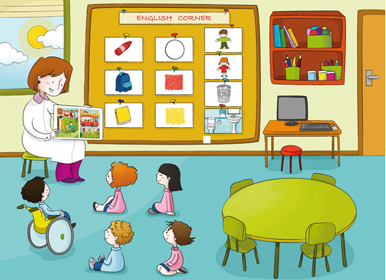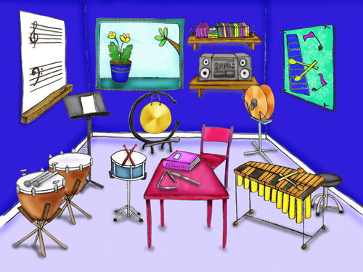

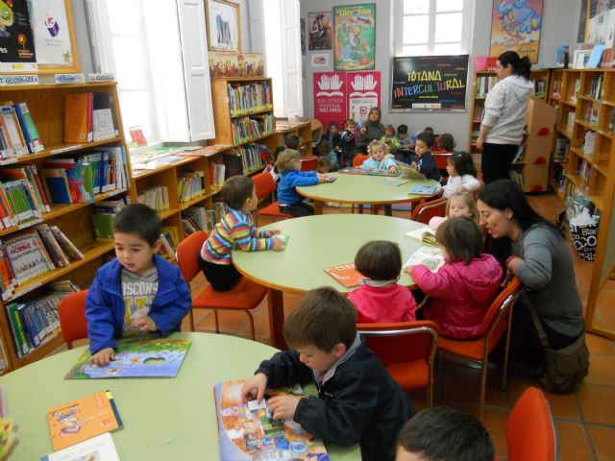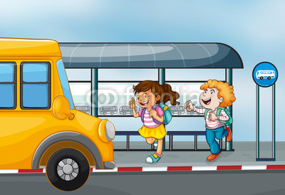

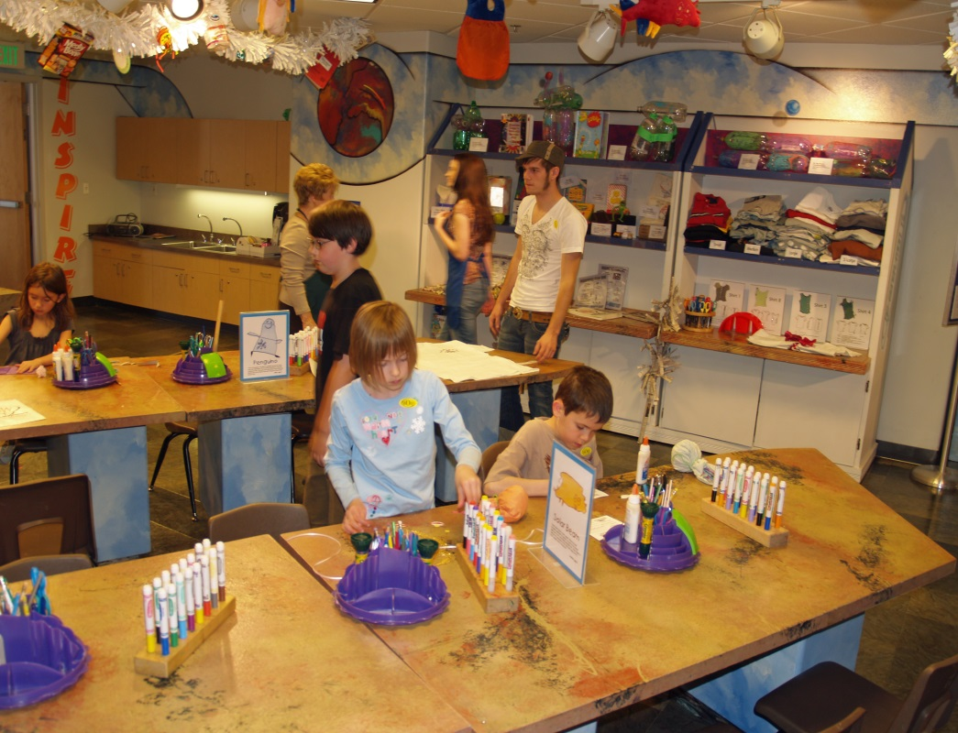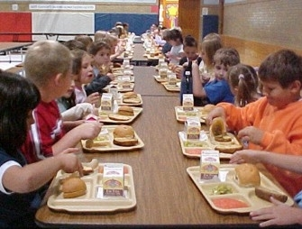

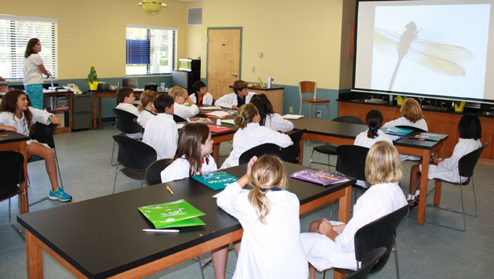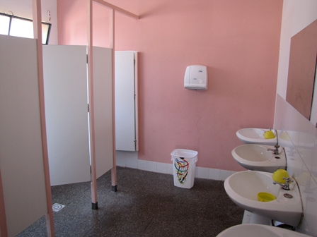

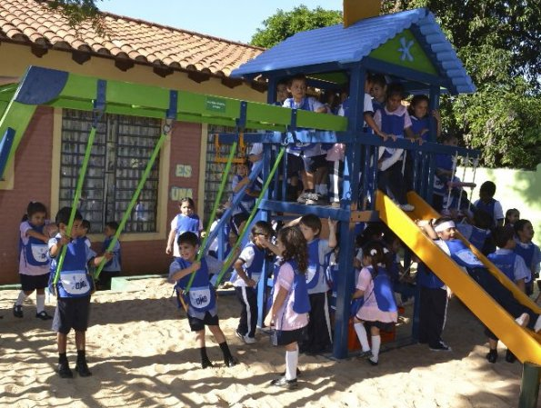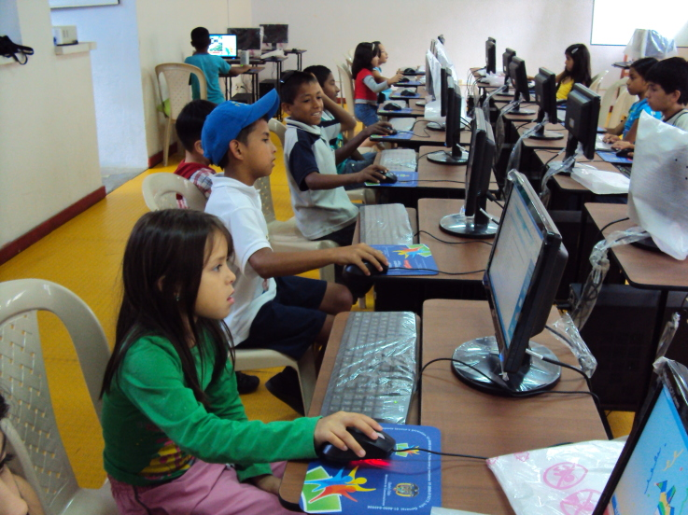

CLASSROOM
CLASSROOM
MUSIC ROOM
LIBRARY
BUS STOP
CLASSROOM
CAFETERIA
SCIENCE ROOM
BATHROOMS
PLAY GROUND
COMPUTER ROOM
COMPUTER ROOM
PLAY GROUND
BATHROOMS
SCIENCE ROOM
CAFETERIA
CLASSROOM
BUS STOP
LIBRARY
MUSIC ROOM

B
C
D
E
A

G
H
I
J
F

L
M
N
O
K

Q
R
S
T
P

